Rangayan:the dramatic society of ARSD College:Street Play

ABOUT US:

Ranagayn is a society that brings together student actors,writers,instrumentalists and creatives to create some of the most vibrant campus theatre. It is a platform that facilitates and enhances the fledgling talents of ARSD College.

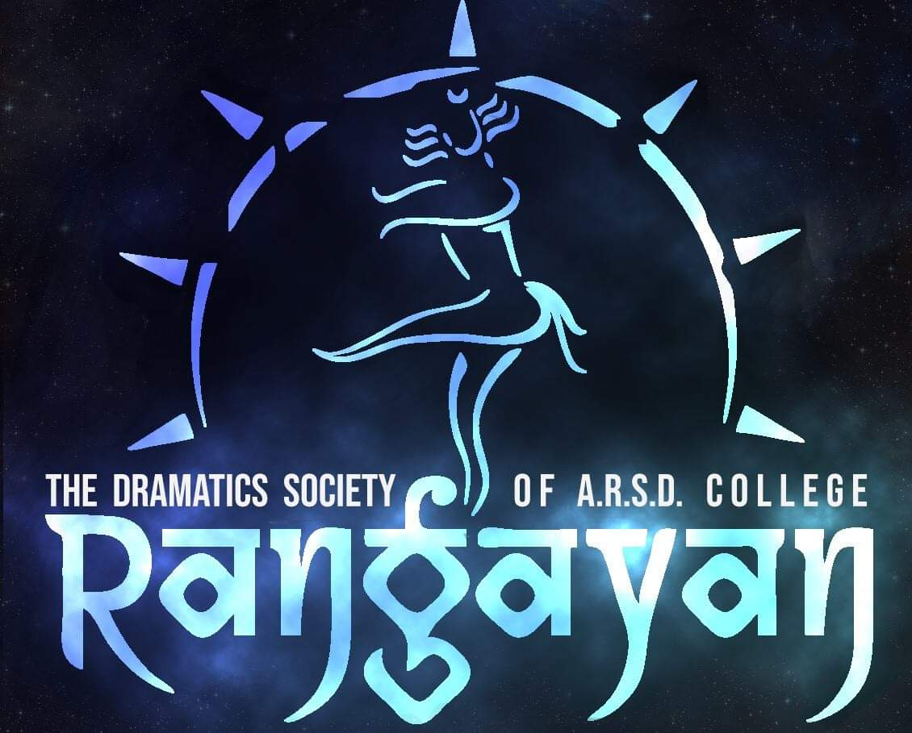

OUR EVENTS AND ACTIVITIES:

Rangayan provides an array of activities.

A theatre workshop is organized at the beginning of the session followed by creative workshops and multiple performance opportunities throughout the year. We also organize a theatre festival titled Rangsheersh Jaidev Theatre Festival, in honour of Dr. Jaidev Taneja, an eminent drama critic.

Rangayan has participated in many competitions and won many laurels.

For example: We bagged positions in the annual fests of AIIMS, IIT Delhi, IIT Kanpur and many more for our street play productions.

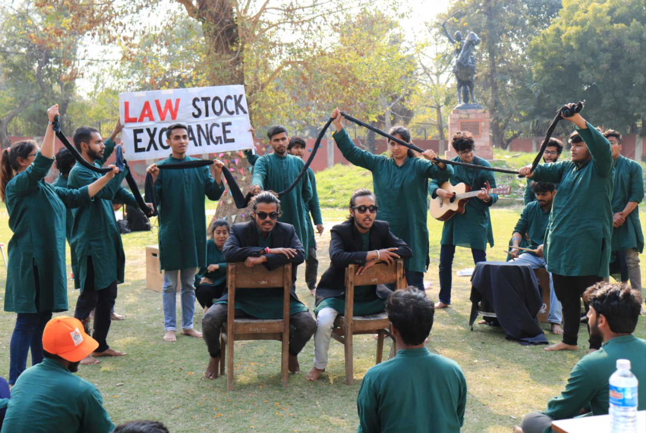

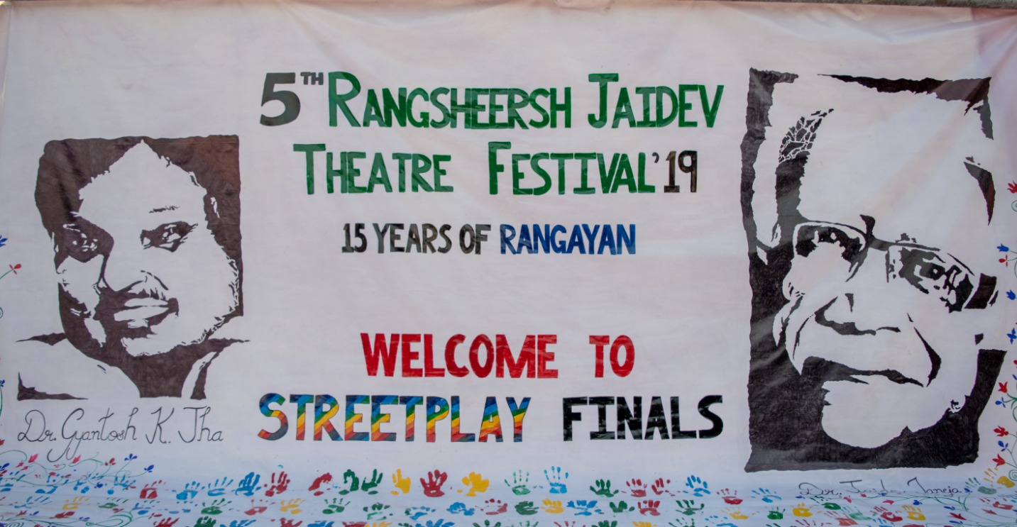

BENEFITS:

Our mission statement is to provide opportunity and inclusiveness. It helps to nurture well-rounded individuals. This certainly provides a chance for students to enhance their cooperation spirits since they need to work hand-in-hand and design plenty of activities. Their self confidence and poise can also be developed.

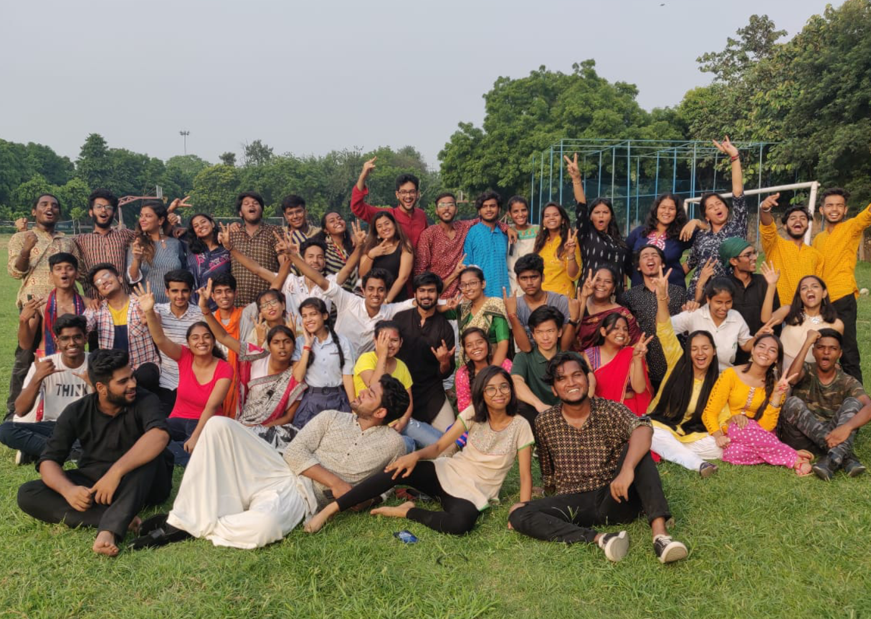

From writing play, to direction and performance, all the members get to learn a lot in an imaginative and unique way.Rangayan brings a myriad of advantages to both students and college.